CENWP-OP-B
09 September 2003
MEMORANDUM FOR THE RECORD

SUBJECT: Dead coho at Bonneville’s Adult Fish Facility (AFF).

- Project biologists were called about a coho mortality that occurred around 0830 on 09 September 2003.
- The unclipped coho had been found in the recovery pool by CRITFC researchers.
- There were no external signs of injury, the eyes were clear, but the gills were pale and brown around the edges.
- The fish was discarded through the glory hole.

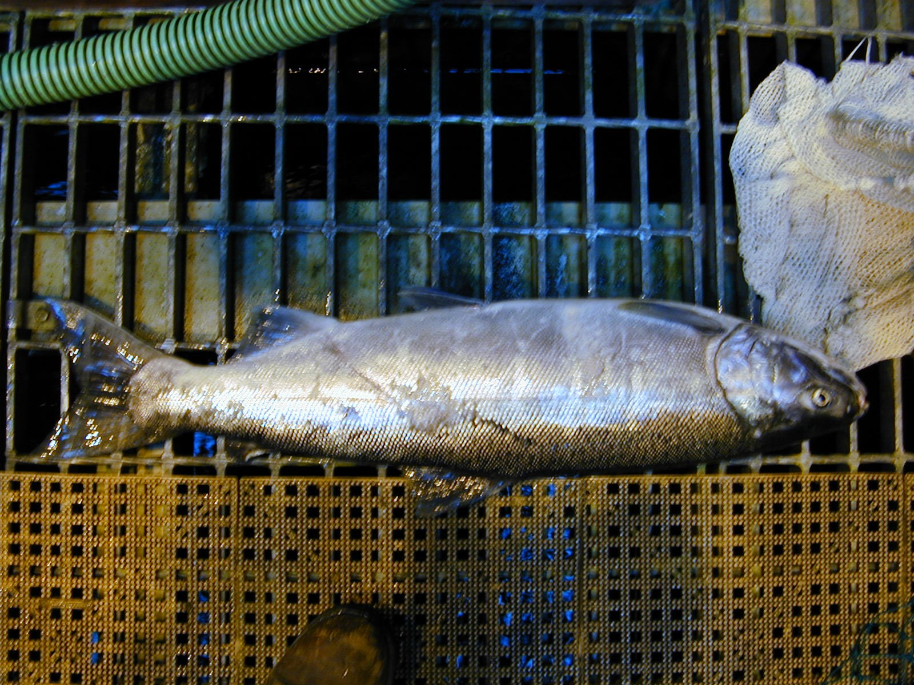

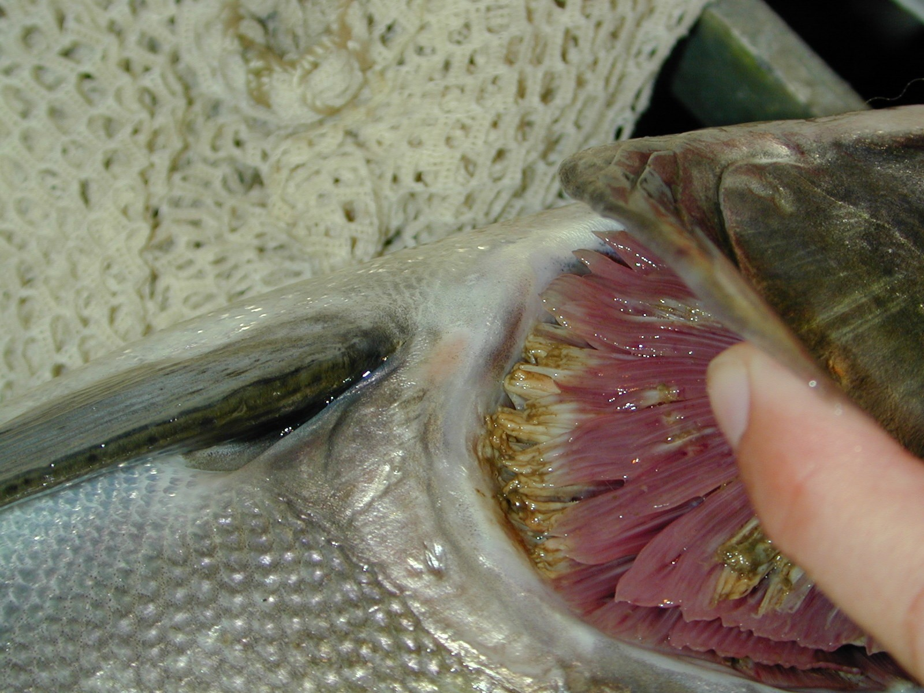

Tammy Mackey
Bonneville Fisheries Biologist

